Advance Excel Assignment 1

1. **What do you mean by cells in an excel sheet?**

**Answer:** A cell is an essential part of MS-Excel. It is an object of Excel worksheets. Whenever you open Excel, the Excel worksheet contains cells to store the information in them. You enter content and your data into these cells. Cells are the building blocks of the Excel worksheet. So, you should know every single point about it.

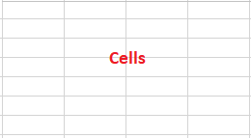

In the Excel worksheet, a cell is a rectangular-shaped box. It is a small unit of the Excel spreadsheet. There are around 17 billion cells in an Excel worksheet, which are united together in horizontal and vertical lines.

An Excel worksheet contains cells in rows and columns. Rows are labeled as numbers and columns as alphabets. It means the rows are identified by numbers and columns by alphabets.

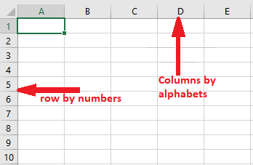

1. **How can you restrict someone from copying a cell from your worksheet?**

**Answer:** 1. First, choose the data you want to protect.

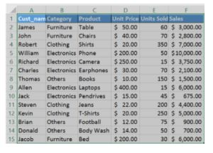

2. Hit Ctrl + Shift + F. The Format Cells tab appears. Go to the Protection tab. Check Locked and click OK.

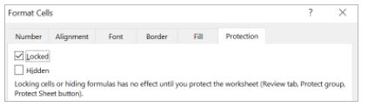

3. Next, go to the Review tab and select Protect Sheet. Enter the password to protect the sheet.

1. **How to move or copy the worksheet into another workbook?**

**Answer:**

The common way to copy a sheet to another workbook is this:

1. Right click on the tab that you want to copy, and then click Move or Copy…
2. In the *Move or Copy* dialog box, do the following:
   * Under *To book*, choose the target file. To place a copy into a new workbook, select *(new book).*
   * Under *Before sheet*, specify where to put the copy.
   * Select the Create a copy box.
   * Click *OK*.

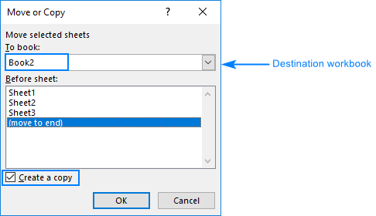

1. **Which key is used as a shortcut for opening a new window document?**

**Answer:** Ctrl + N - Open new window

1. **What are the things that we can notice after opening the Excel interface?**

**Answer:** 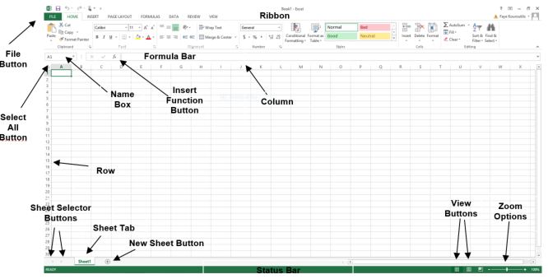

|  |  |
| --- | --- |
| **Interface Element** | **Description** |
| **Ribbon Tabs** | **Ribbon Tab is a tab that organizes commands by topic** |
| **The Ribbon** | **Commands underneath the Tabs** |
| **Ribbon Groups** | **Grouping of related commands** |
| **Dialog Box Launcher** | **Opens a dialog box that includes additional commands** |
| **Quick Access Toolbar** | **One click access to any frequently used command** |
| **Name Box** | **Displays cell location and can be used to navigate to a cell location** |
| **Select All Button** | **Selects all the cells in a worksheet** |
| **Formula Bar** | **View, enter, or edit cell contents** |
| **Insert Function Button** | **Displays Insert Function dialog box** |
| **Scroll Bars** | **Used to navigate up, down, left & right** |
| **Zoom Slider** | **Zoom into an area of the worksheet** |
| **View Buttons** | **Switch between Normal, Page Layout and Page Break Preview views** |
| **Worksheet tabs** | **Tabs used to select individual worksheets** |
| **The Workspace** | **The area inside of the columns and rows used in Excel** |
| **Columns** | **Columns use letters** |
| **Rows** | **Rows use numbers** |

**Ribbon Overview**

* **Home - Most commonly used buttons and includes common functions, sorting, etc.**
* **Insert - For inserting Tables, Illustrations, Charts, Links and Text Objects**
* **Page Layout - For Themes, Page Setup, Scaling, Sheet Options and Arrangement of drawing objects**
* **Formulas - For inserting Functions, Range Names, Formula Auditing, and Calculations Options**
* **Data - For Database Options (Filter/Sort, Data Tools, and Outlining)**
* **Review - For Proofing, Comments, Protection, and Track Changes**
* **View - For Workbook Views, Show/Hide, Zoom, Window options, and Macros**

1. **When to use a relative cell reference in excel?**

**Answer:** By default, all cell references are relative references. When copied across multiple cells, they change based on the relative position of rows and columns. For example, if you copy the formula =A1+B1 from row 1 to row 2, the formula will become =A2+B2. Relative references are especially convenient whenever you need to repeat the same calculation across multiple rows or columns.